**Exposé Masterarbeit - Stand 01.04.2019**

**„Setup a Lane keeping assistance system evaluation demonstration using NXP SBC-S32V234 Evaluation Board and simulator “**

**1.Background:**

The main objective of this master thesis is to detect the lane view and calculate the distance to lane using SBC-S32V234 NXP Board and three different cameras which will provide front view, left view and right view of lane. The fusion of the camera data will assist in the LKA evaluation. The topics which will be discussed throughout this concept paper of master’s thesis are: Goal of the project, Project structure, Overview of software and Hardware, project plan, lessons learned and work progress.

**2.Goal:**

1.At first the NXP hardware will be evaluated for the autonomous validation Features e.g. LKAS.

2.The scenario on the simulator will be created and stream the video and environment parameters.e.g.CAR MAKER, VTD.

3.Camera setup in front of monitor with necessary covering? So that we images of less noise

4.Required Hardware setup(cameras will be focused to 3 simulator display which will display left side view, right side view and front view of lane.)

5.At least 3 cameras should be connected with Board to provide 3 different video data which are left side view, right side view, dashboard view.

6.The board should provide 1 CAN Bus data and 1 Ethernet data and at least 3 camera inputs.

7.The camera images will be grabbed into the board via 3 cameras.

8.Image processing and calculation of required parameters will be done on NXP Boards.

9.The processed image and required parameters will be sent to simulator via CAN Bus or Ethernet Bus.

10.The calculated data will be compared with ground truth simulated environment.

11.Errors is communicated to the processing unit for fine tuning the processing algorithm.

**3.Project Structure:**

dsfdssdf

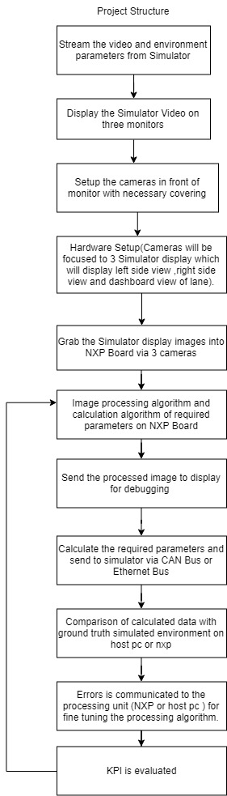

**4.Project Milestone:**

|  |  |  |  |  |  |  |  |  |  |  |  |  |  |  |  |  |  |  |  |  |  |  |  |  |  |
| --- | --- | --- | --- | --- | --- | --- | --- | --- | --- | --- | --- | --- | --- | --- | --- | --- | --- | --- | --- | --- | --- | --- | --- | --- | --- |
| Project Name:Setup a Lane keeping assistance system evaluation demonstration using NXP SBC-S32V234 Evaluation Board | | | | | | | | | | | | | | | | | | | | | Date:24.05.19 | | | | |
| Year | 2019 | | | | | | | | | | | | | | | | | | | | | | | | |
| Month | April | | | | May | | | | June | | | | July | | | | August | | | | | September | | | |
| Week | 1 | 2 | 3 | 4 | 5 | 6 | 7 | 8 | 9 | 10 | 11 | 12 | 13 | 14 | 15 | 16 | 17 | 18 | 19 | 20 | | 21 | 22 | 23 | 24 |
| S32V234 Board Evaluation |  |  |  |  |  |  |  |  |  |  |  |  |  |  |  |  |  |  |  |  | |  |  |  |  |
| S32DS Software Installation |  |  |  |  |  |  |  |  |  |  |  |  |  |  |  |  |  |  |  |  | |  |  |  |  |
| Running Demo project on Emulator |  |  |  |  |  |  |  |  |  |  |  |  |  |  |  |  |  |  |  |  | |  |  |  |  |
| Preparation of SD Card |  |  |  |  |  |  |  |  |  |  |  |  |  |  |  |  |  |  |  |  | |  |  |  |  |
| Creation of own Demo Project |  |  |  |  |  |  |  |  |  |  |  |  |  |  |  |  |  |  |  |  | |  |  |  |  |
| Camera setup |  |  |  |  |  |  |  |  |  |  |  |  |  |  |  |  |  |  |  |  | |  |  |  |  |
| Analyzing Vision SDK architecture and change in required programming |  |  |  |  |  |  |  |  |  |  |  |  |  |  |  |  |  |  |  |  | |  |  |  |  |
| Image processing and calculation of required parameters on NXP Board |  |  |  |  |  |  |  |  |  |  |  |  |  |  |  |  |  |  |  |  | |  |  |  |  |
| Sending Image and required parameters to Simulator via CAN bus and Ethernet Bus |  |  |  |  |  |  |  |  |  |  |  |  |  |  |  |  |  |  |  |  | |  |  |  |  |
| Comparison of calculated data with ground truth Simulated Environment |  |  |  |  |  |  |  |  |  |  |  |  |  |  |  |  |  |  |  |  | |  |  |  |  |
| Probable errors fine tuning |  |  |  |  |  |  |  |  |  |  |  |  |  |  |  |  |  |  |  |  | |  |  |  |  |
| Documentation and writing thesis report |  |  |  |  |  |  |  |  |  |  |  |  |  |  |  |  |  |  |  |  | |  |  |  |  |

**5.Cost Analysis:**

|  |  |  |  |  |  |  |
| --- | --- | --- | --- | --- | --- | --- |
|  |  | Cost in € | | | | |
| Quantity | Work packages | Preparation | Measurement Setup | Execution | Report | **Total** |
| 1 | NXP SBC-S32V234 Board |  |  |  |  | **626.290**€ |
| 8 | MXOV10635-S32V Camera |  |  |  |  | **1158**€ |
| 3 | MAXIM deserializer |  |  |  |  | **106.150**€ |
| 4 | Monitors(3) |  |  |  |  | **450**€ **approx.** |

**6.Overview of the NXP Board and software:**

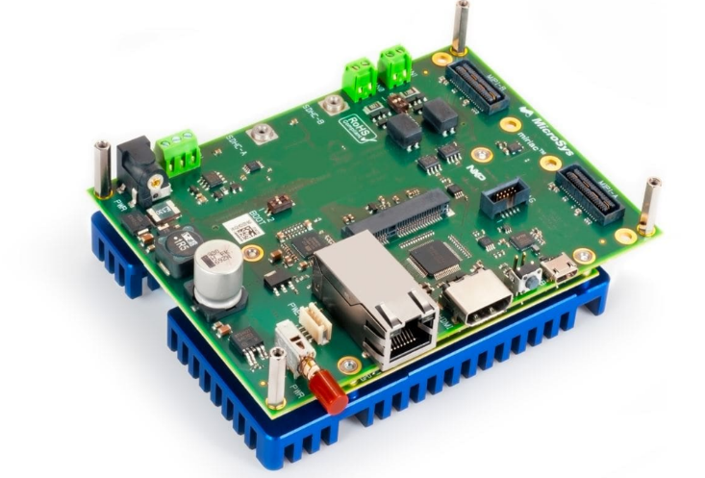

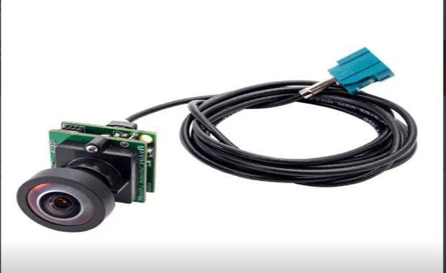

Figure1:SBC-S32V234 Evaluation Board and MXOV10635-S32V Camera

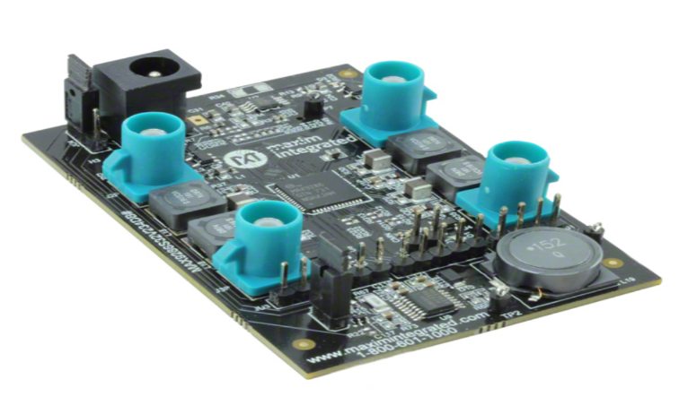

Figure2: Maxim Deserializer

The SBC-S32V234 is a low-cost development platform for the S32V2 vision processor.(reference). The Module board contains S32V234 processor, memories and power regulators for the module board and the Carrier board contains all system specific i/o like camera connectors, ethernet port, display port, SD card slot, CAN ports etc.Total 8 cameras can be connected to the Board through deserializer.In this project MXOV10635-S32V camera have been used. The deserializer board model is MAX9286S32V234.S32DS 2018.R1 for Vision software will be used for simulation.

**7.Lesson learned, Work progress and Challenges:**

At first S32DS 2018.R1 software were installed on Ubuntu 18.4. But S32 DS for Vision only supports Ubuntu 16.4 and openjdk-8. After installing Ubuntu 16.4 and openjdk-8 the required software has been installed successfully. From APEX graph project APEX program project and APEX application project is created accordingly using S32DS software on Linux. ISP dataflow project and ISP application project is also created using S32DS for vision software.

Hardware Setup:

1. On S32-SBC PWA jumper connected to 12V power to power deserializer board.

2. On S32-SBC the MAX deserializer board is connected to the MIPI-A.

3. On MAX deserializer board jumper JU4 is set to power the camera from SBC board (After setting the jumper the yellow light of each cameras are lit).

The full hardware setup image is given below:

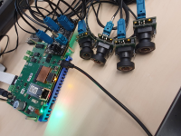

Figure3: Hardware Setup

Software Setup**:**

The SD card is prepared with SDK_S32V2_RTM_1_3_0_img_yocto.tar.gz.After preparing the sd card it is inserted to the evaluation board. Camera captured images will be displayed on the HDMI connected display unit. Power on the boot, login and change directory to the demo folder.Then the sample application isp_ov10635_quad.elf was running on the board using the command

root@s32v234sbc:~/vsdk# ./isp_ov10635_quad.elf.

The VSDK architecture is analyzed.The new APEX2 kernel project is created.The upsampling and downsampling of image is done using own developed kernel and prebuilt kernel.The RGB image converted to Grayscale image using APEX core framework. ~~Now RGB image to RGB image conversion work is going on. We are getting some stripes on our output image while using our own developed kernel.The frame output buffer configuration is also done to display larger image.Now~~